
CC-215-L: Database Systems Lab

Faculty of Computing & Information Technology

BS(IT/CS) Morning - Fall 2023
LAB – 02
The objective of this lab is to:
- NVL
- Concatenation
- Like Operator, Order By Clause
- Character & Number Functions
Course & Lab Instructor: Dr. Asif Sohail
LAB TIMING : 90 MINS
TOTAL MARKS : 45
- Kindly paste the query as well as result table screenshot as a result of each task
Task 01: [15 marks]
- Write an SQL query to display the names of all employees starting with the letter ‘S’.
SELECT ename
FROM emp
WHERE ename LIKE 'S%';
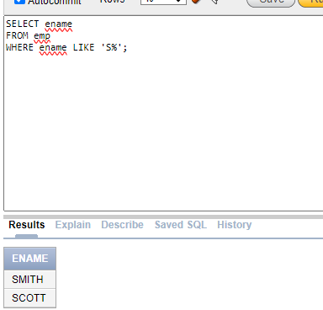
- Display the employees who earns “NO COMMISION”.
select ENAME
from EMP
where COMM is NULL;
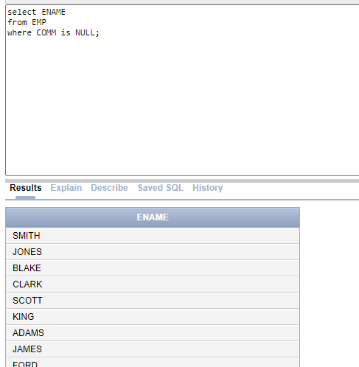
- Display the current month. The column name should also mention “Current Month”.
SELECT EXTRACT(MONTH FROM SYSDATE) as "CURRENT_MONTH" FROM DUAL;
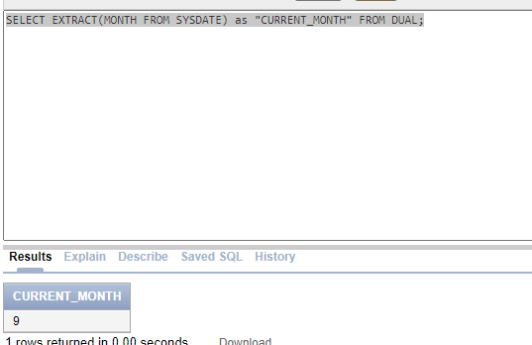
- Display the Employees Annual salary having Annual Salary Greater than 20,000.
select ENAME,SAL,SAL*12 as "ANN-SAL"
from EMP
where SAL*12>20000;
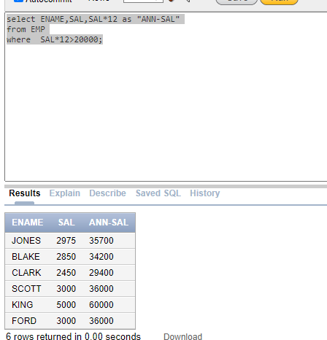
- List the names of employees whose salary is an even number.
select ENAME,SAL,MOD(SAL,2)
from EMP
where MOD(SAL,2)=0;
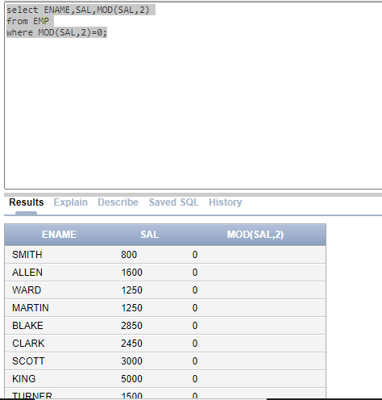
- Display the names of employee in lower letter case.
select LOWER(ENAME)
from EMP;
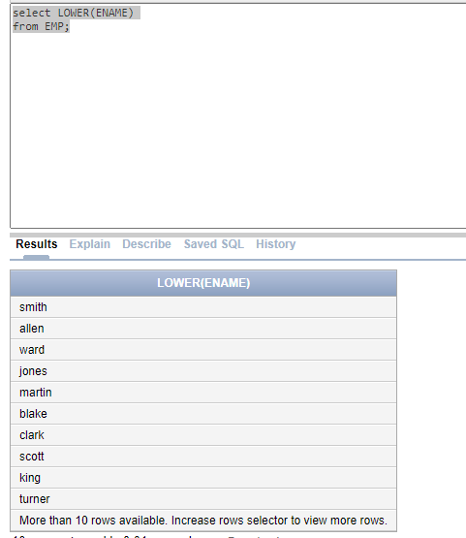
- Display the employees earning salaries in the multiple of 500.Employee earning nothing should not be displayed.
SELECT ENAME
FROM EMP
WHERE MOD(SAL,500) = 0 and SAL > 0;
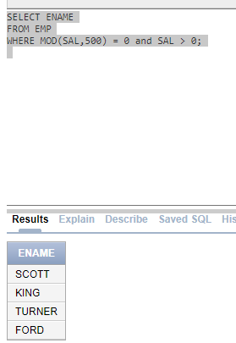

- Find the second occurrence index of the word “OR” in the string “CORPORATE FLOOR”.
SELECT INSTR('CORPORATE FLOOR', 'OR', INSTR('CORPORATE FLOOR', 'OR') + 1)
FROM DUAL;
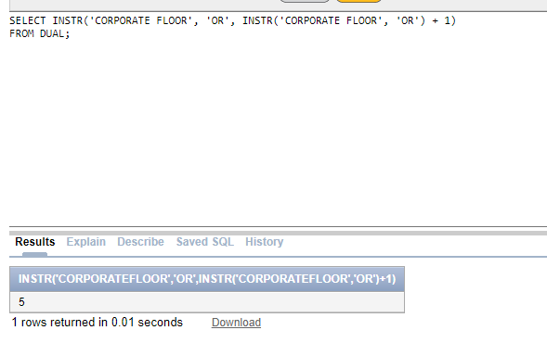

- Display Ename,JOB and find the per/day salary of the employees. The salary should be rounded off upto 2 decimal places.
select ENAME,JOB, SAL,ROUND(SAL/30,2) as "SAL_PER_DAY" from EMP
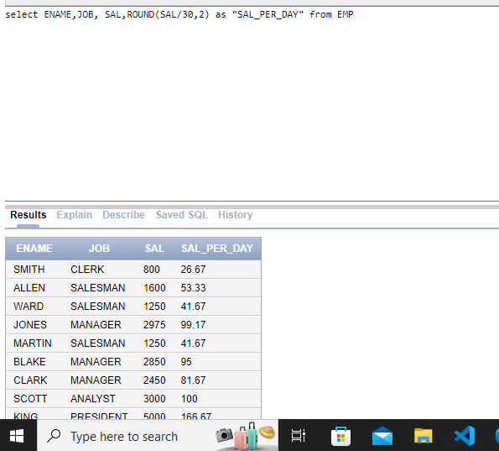
- Display the following output. Don’t use CONCAT FUNCTION.
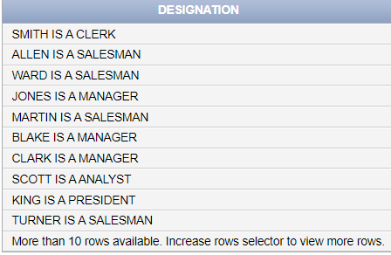
select ENAME || ' is a ' || JOB from EMP;
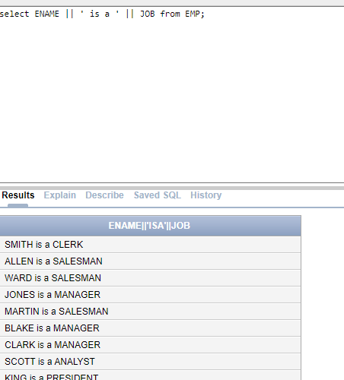
- Display the enames as the combination of first two letters and last two letters. Such as “Smith as Smth” etc.
SELECT SUBSTR(ENAME, 1, 2) || SUBSTR(ENAME, LENGTH(ENAME) - 1, 2) AS "Modified_name"
FROM EMP;
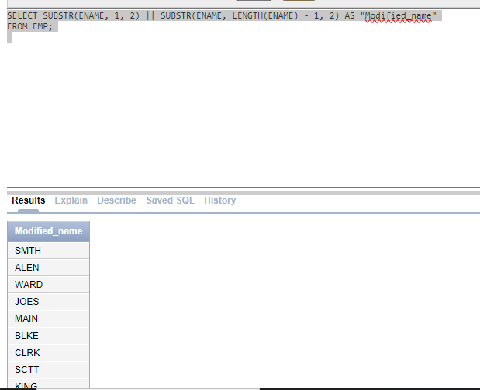
- List the employees hired in 1980 or 1981.
SELECT ENAME, HIREDATE
FROM EMP
WHERE EXTRACT(YEAR FROM HIREDATE) IN (1980, 1981)
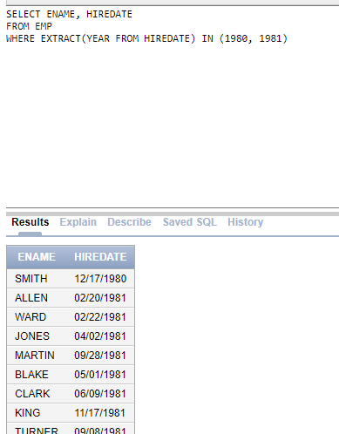
- List all employees in decreasing order of commission (Commission should be considered 0 when null).
select ENAME,NVL(COMM,0) from EMP
ORDER BY COMM DESC;
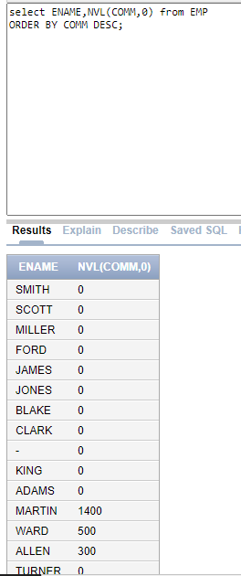
14. Display salary in format given below.
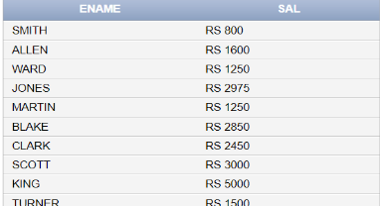

select ENAME,CONCAT(‘RS ’, SAL) from EMP;
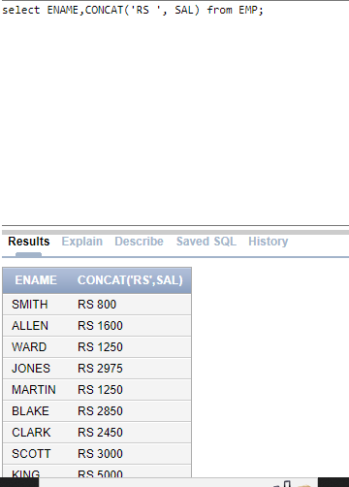
15. Find the experience of employee in years.
HINT: SYSDATE – HIREDATE tells the total number of days
select ENAME,FLOOR(SYSDATE-HIREDATE)/365) AS "IN YEARS" FROM EMP;
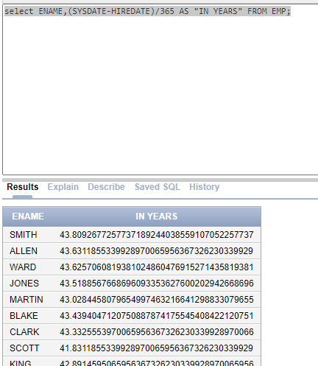

Task 02: [16 marks]
- Write an SQL query to display the name of the employee having “A” as a third letter.
select ENAME FROM EMP
where ENAME LIKE '__A%'
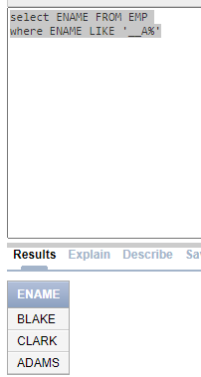
- Find the occurrences of Letter ‘T’ in names of the employee.
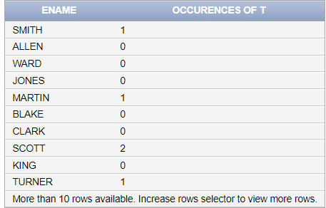
SELECT ENAME,
LENGTH(ENAME) - LENGTH(REPLACE(ENAME, 'T', '')) AS "Occurrences of T"
FROM EMP;

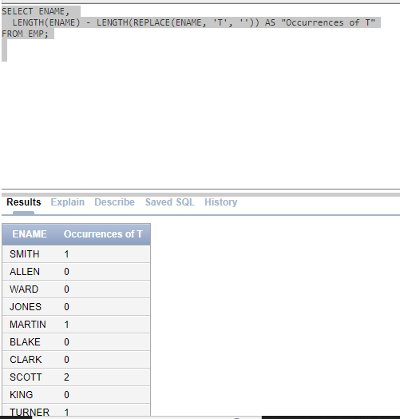
- Find the total words in the name of each student in PUCIT table. For example, the name “Hazeez Haider” has two words.
SELECT STD_NAME, LENGTH(STD_NAME) - LENGTH(REPLACE(STD_NAME, ' ', '')) + 1 AS "Total Words"
FROM PUCIT;
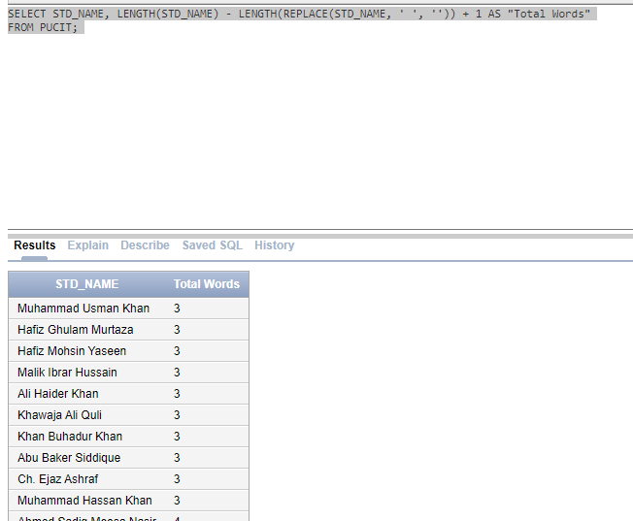

- Write an SQL query that contains Letter ‘L’ on second position and ends with ‘E’ in employees’ names. (Use of Character Functions is not allowed)

SELECT ENAME
FROM EMP
WHERE SUBSTR(ENAME, 2, 1) = 'L' AND SUBSTR(ENAME, -1) = 'E';
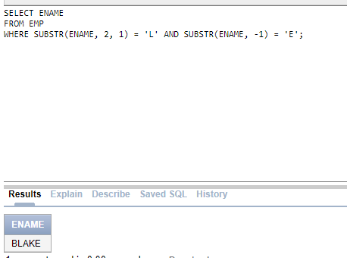

- Display the EMPNO along with its reversed number.
SELECT empno, REVERSE(CAST(empno AS CHAR)) AS reversed_empno
FROM emp;
SELECT EMPNO, REVERSE(TO_CHAR(EMPNO)) AS "reverse_empno"
FROM EMP;

- Write an SQL query to display the ename such that the first and last letters are in lowercase, while the rest are in uppercase. For example: 'sMITh', 'aLLEn'.
SELECT ENAME, LOWER(SUBSTR(ENAME, 1, 1)) || UPPER(SUBSTR(ENAME, 2, LENGTH(ENAME) - 2)) || LOWER(SUBSTR(ENAME, -1)) AS "formatted_ename"
FROM EMP;

- Write an SQL query that first extracts the day from the Hiredate. Then, display the corresponding week number for that day. For example, Day number 17 lies in the 3rd week.
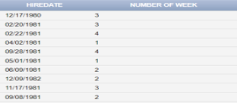
SELECT HIREDATE, CEIL(EXTRACT(DAY FROM HIREDATE) / 7) AS "week_number"
FROM EMP;
- Create a Salary Bar (Histogram) as shown. You can use “█” symbol to create the chart.
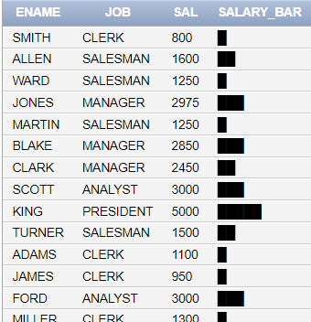
SELECT ENAME, SAL, LPAD('█',(SAL/800),'█') as "SAL_BAR"
FROM EMP;
Task 03: [9 marks]
      - Write an SQL query to Display the odd length names in the following format.
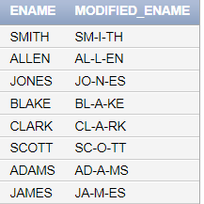
SELECT ename AS "original_name", SUBSTR(ename, 1, 2) || '-' || SUBSTR(ename, 3, 1) || '-' || SUBSTR(ename,4) AS "UPDATED_NAME"
FROM EMP

      - Write a query that achieves the following:
Round Salaries: Round each employee's salary to the nearest hundred.
Set Commission: For employees with no commission, set their commission to 15% of their salary.
Calculate Final Salary: Add the updated salary and updated commission to get the final salary.
Calculate Annual Salary: Using final salary, calculate the annual salary of each employee.
Sort and Display: Display the table in ascending order based on the annual salary.
SELECT ENAME, ROUND(SAL, -2) AS "Rounded Salary", NVL(COMM, SAL * 0.15) AS "Updated Commission", (ROUND(SAL, -2) + NVL(COMM, SAL * 0.15)) AS "Final Salary",
(ROUND(SAL, -2) + NVL(COMM, SAL * 0.15)) * 12 AS "Annual Salary"
FROM EMP
ORDER BY "Annual Salary" ASC;
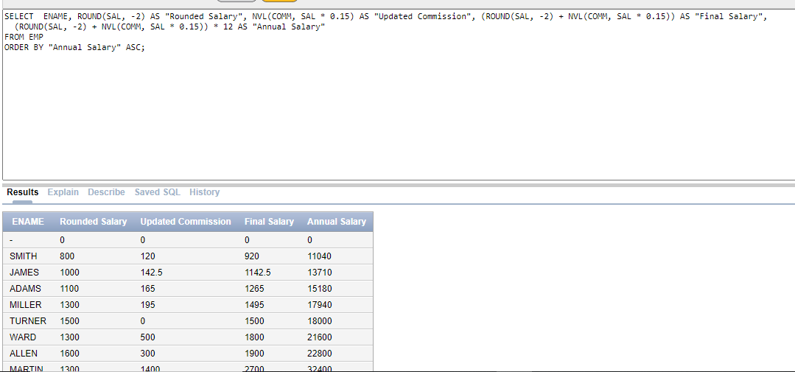
      - Display the names of employees after removing the last two letters from each name. Additionally, replace each vowel in the remaining part of the name with a corresponding digit. For example ‘A’ is replaced by ‘1’.
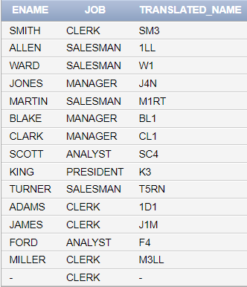
Select ENAME,JOB,TRANSLATE(SUBSTR(ENAME,1,3),'AEIOU','12345') AS "TRANSLATED_NAME" from EMP;
Task 04: [5 marks]
VIVA VOCE

